EXPERIMENT – 14 Create a Virtual Hard Disk and allocate the storage using Vmware Workstation.

Aim:

To create and allocate a Virtual Hard Disk (VHD) for a virtual machine using VMware Workstation.

Procedure:

1. Open VMware Workstation on the host device.
2. Select the Virtual Machine in which the new hard disk is to be created.
3. Go to VM → Settings → Hardware tab.
4. Click Add → Hard Disk → Next.
5. Choose the disk type (SCSI / SATA / NVMe) and continue.
6. Select Create a new virtual disk and click Next.
7. Specify the disk size (e.g., 40 GB) and choose whether to:
   * Store as a single file, or
   * Split into multiple files.
8. Assign the file location and disk name, then finish the setup.
9. Start the Virtual Machine and open the Disk Management utility inside the OS.
10. Initialize the new disk, create a partition, and format it (NTFS/EXT4).
11. Verify that the allocated virtual disk is now available for use.

Output:

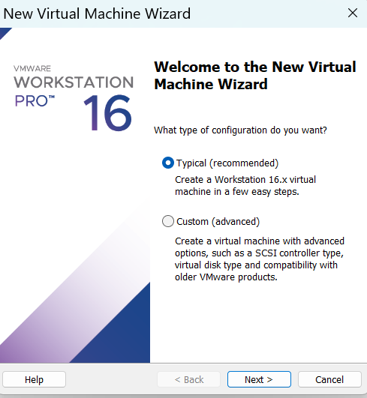

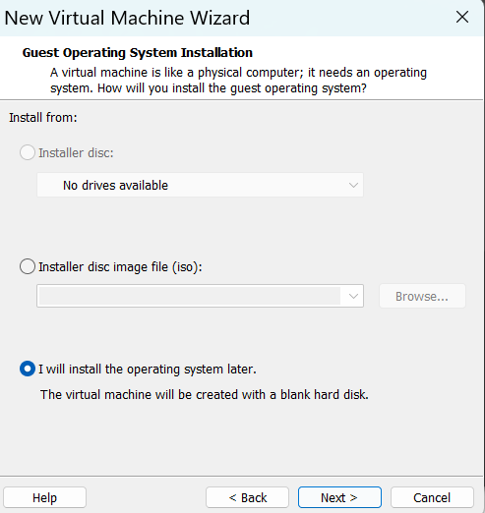

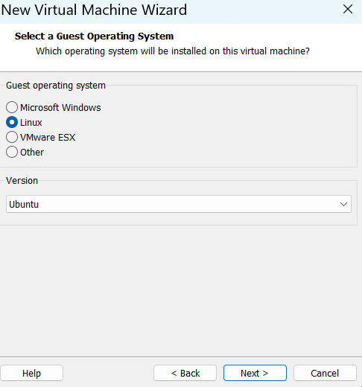

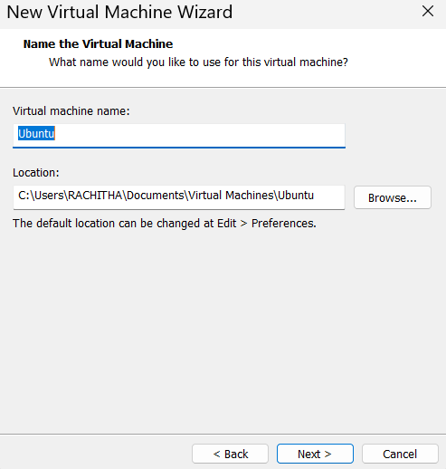

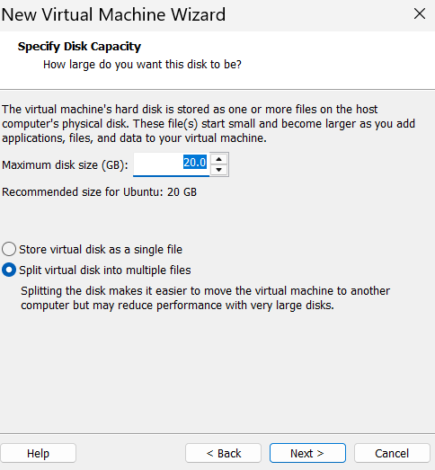

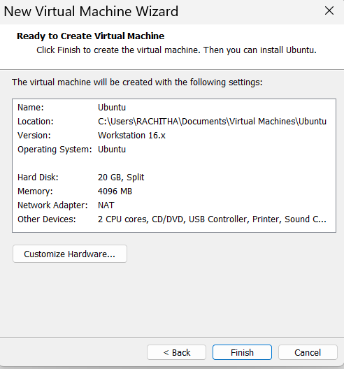

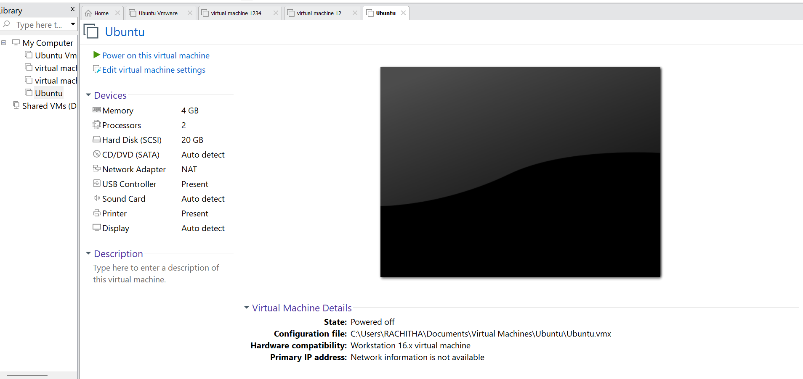

Result:

A Virtual Hard Disk (VHD) was successfully created and storage was allocated to the virtual machine in VMware Workstation. The disk was initialized, partitioned, and formatted, making it ready for data storage.